GAIT BARROWS NATIONAL NATURE RESERVE
LITTLE HAWES WATER PROJECT
DROP IN @ GASKELL HALL
If you’d like to find out more about the restoration plans for Little Hawes Water at Gait Barrows National Nature Reserve, Natural England will be hosting a drop in session at The Green Room, Gaskell Hall in Silverdale between 10am and 1pm on Saturday 3rd Feb.
Feel free to pop in and say hello. We’ll have information and maps about the project and we’d be happy to answer any questions you may have. Alternatively, feel free to get in touch with Glen Swainson (Senior Reserve Manager at Gait Barrows) at glen.swainson@naturalengland.org.uk if you have any other queries.
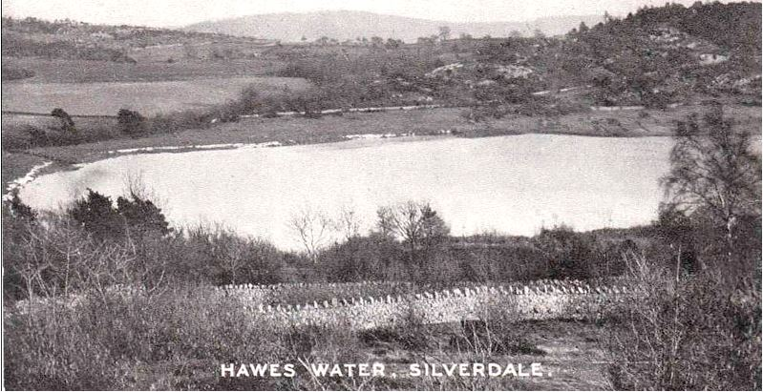
North End of Hawes Water circa 1900.

